Chapter5
Experimental Results and Analysis

5.1 Experimental Setup
The experimental setup defines the procedures, configurations, and evaluation criteria used to assess the proposed Real-Time Automated Cyber Threat Classification and Emerging Threat Detection Framework. The experiments were designed to evaluate the capability of the proposed framework to classify cyber threats accurately, identify temporal patterns in threat-related information, and detect emerging threat trends. The overall experimental process consists of data preparation, feature extraction, model training, classification, temporal analysis, and performance evaluation.

5.1.1 Experimental Workflow
The experimental workflow consists of the following major stages:
- Dataset Collection: Cyber Threat Intelligence (CTI) reports and threat-related records are collected from the selected dataset/source.
- Data Preprocessing: Duplicate records, missing values, irrelevant information, and noisy text are handled. Text normalization and other preprocessing operations are performed.
- Feature Extraction: Relevant textual and/or structured features are extracted from the processed CTI records.
- Dataset Splitting: The processed dataset is divided into training and testing subsets while maintaining appropriate class representation.
- Model Training: Selected machine learning and baseline classification algorithms are trained using the training dataset.
- Threat Classification: The trained models classify CTI records into their corresponding cyber-threat categories.
- Temporal Topic Analysis: Threat-related topics are identified and their evolution over time is analyzed to determine changes in cyber-threat patterns.
- Emerging Threat Detection: Newly appearing, increasing, or unusual threat topics are analyzed as potential emerging threats.
- Performance Evaluation: Classification performance is measured using accuracy, precision, recall, F1-score, and confusion matrices.
- Comparative Analysis: The performance of different models is compared to identify the most effective approach for automated cyber-threat classification.

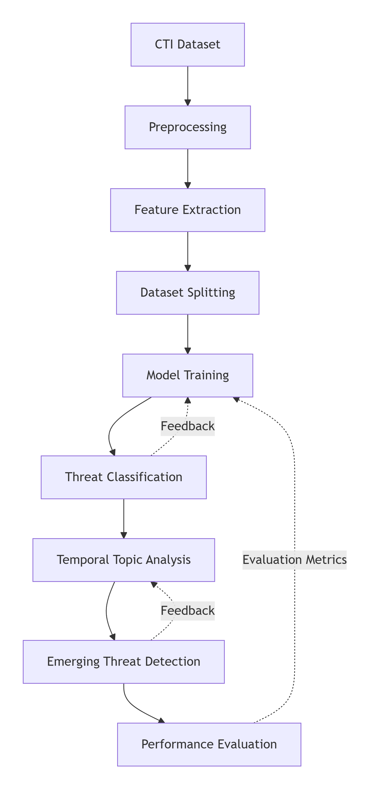

This workflow ensures that the experimental evaluation covers both the classification capability and the temporal/emerging-threat detection capability of the proposed framework.
5.1.2 Train/Test Configuration
For supervised classification experiments, the processed dataset is divided into training and testing subsets. The training set is used to learn the relationship between extracted features and predefined cyber-threat categories, while the testing set is kept separate and is used to evaluate the generalization capability of the trained models.
A standard train-test configuration is used in which approximately 80% of the available records are allocated for training and 20% for testing. Where required, the training data may further be divided into training and validation subsets for hyperparameter selection.

Dataset Subset | Purpose | Proportion
Training Set | Model learning | 80%
Testing Set | Final performance evaluation | 20%

The split is performed before final model evaluation to prevent information from the testing dataset from influencing the training process. Where class imbalance exists, stratified splitting is preferred so that the major threat categories are represented appropriately in both subsets.
For temporal experiments, the chronological order of CTI records is preserved where applicable. This prevents information from future records from being inadvertently used to predict earlier threat patterns and provides a more realistic representation of emerging-threat detection.
5.1.3 Evaluation Procedure
The trained models are evaluated using quantitative performance measures suitable for multi-class cyber-threat classification. The primary evaluation metrics are accuracy, precision, recall, and F1-score.
Accuracy measures the proportion of correctly classified CTI records among all evaluated records:
Accuracy=TP+TNTP+TN+FP+FNAccuracy = \frac{TP+TN}{TP+TN+FP+FN}
where TPTP, TNTN, FPFP, and FNFN represent true positives, true negatives, false positives, and false negatives, respectively.
Precision measures how many records predicted as a particular threat category actually belong to that category:
Precision=TPTP+FPPrecision = \frac{TP}{TP+FP}
Recall measures the ability of the model to correctly identify records belonging to a particular threat category:
Recall=TPTP+FNRecall = \frac{TP}{TP+FN}
F1-score provides a balanced measure of precision and recall:
F1=2×Precision×RecallPrecision+RecallF1 = 2 \times \frac{Precision \times Recall}{Precision+Recall}
For multi-class classification, macro-average and weighted-average scores can also be reported to provide a more comprehensive evaluation, particularly when the dataset contains imbalanced threat categories.
In addition to numerical metrics, confusion matrices are generated to examine class-wise prediction errors. The confusion matrix helps identify which threat categories are correctly classified and which categories are frequently confused with one another.
For the temporal component, the framework evaluates changes in topic frequency and distribution across different time periods. Topics showing significant growth, sudden appearance, or unusual temporal behavior are examined as potential indicators of emerging cyber threats.
Finally, the results of all baseline and proposed models are compared to determine the effectiveness of the proposed framework in terms of classification accuracy, threat-category recognition, temporal trend identification, emerging-threat detection, and computational efficiency.

